JOURNAL OF PROCEEDINGS AND MINUTES OF THE CHASE COUNTY, KANSAS
BOARD OF COUNTY COMMISSIONERS

August 31,2021

August 31,2021 at 10:00 am;Anthony Hazelton-Chairman, Randy Talkington-Vice chairman, Matt Miller-member,Connie Pretzer-County Clerk assembled in the Chase County Commission Chambers. Also present was Emporia Gazette Reporter Zach Deloch. Hazelton opened the meeting with the Pledge of Allegiance.

Motion to approve 08/31/2021 Warrants by Hazelton was 2nd by Talkington. Motion carried 3-0.

Motion to approve 07/25/21 to 08/24/21 payroll by Hazelton was 2nd by Talkington. Motion carried 3-0.

Motion to approve Minutes of August 16,2021 by Hazelto_n was 2nd by Talkington. Motion carried 3-0.

Commissioners reviewed requested wage adjustments for Road & Bridge department.
Motion to approve adjustments by Miller was 2nd by Talkington. Motion carried 3-0.

Ben Retter of US Stone and Howard Chapman of Chapman/Turner Limestone LLC continued discussion with the Commissioners on the truck route/Middle Creek Road. Retter has made progress on possible solutions such as re-enforcing the two bridges on Middle Creek Road or applying dust control on the truck route. Retter has purchased equipment to apply the dust control chemical but would ask for county help in the form of a water truck and driver to wet the road prior to chemical application. Commissioners reiterated their stance on keeping heavy truck traffic off of the chip/sealed road. Motion by Miller to give one last extension until the September 13th meeting for USStone to use Middle Creek Road. After September 13th, this will be a closed issue and truck routes and weight restrictions on bridges will be enforced on all County roads and the approved truck routes will remain in effect. Motion was 2nd by Talkington and carried 3-0. Sheriff Dorneker questioned whether the truck routes were under County Resolution or do they fall under the state statute for overweight.
Attorney Halvorsen clarified that Truck Routes are a right granted to a truck driver. This right can be bestowed by the Road & Bridge supervisor,the County Sheriff or by Commission action. The statutory weight limit maximum is 85,500. If the road supervisor wants to post weight limits below that amount it will require resolution.

Register of Deeds Kathy Swift requested approval from the Board to apply for approximately
$75,000 of ARPA fundingto digitalize records in her office. Commissioners gave Swift

permission to proceed.

Presentations were heard from 3 insurance agents for the County employee health insurance. Greg Watkins of Watco Benefit Group had a quote from United Health Care with an effective date of October 1st. Watkins showed various health insurance plans with UHC including an HSA and emphasized the importance of having an insurance team that is able to work for our County employees. Watkins recommends takingthe contract with UHC which would save the county approximately $50000 the 1st year and then explore other options such as an HSA.

Gary Davis of Cornerstone Companies also had quotes from United Health Care insurance company. Davis presented a blueprint of steps that should be accomplished throughout the year. The quote from UNC focused on census data provided by the County Clerk. A more accurate quote from other health insurance companies could be accomplished but employees would need to fill out a form asking personal health questions. Cornerstone Companies is willingto eliminate the commission on the UHC quote ($24,000) which would reduce the rate by $30 per employee and bill separately a fee of $20,000.

Darren Booth of Theel Insurance introduced 3rd party administrator,Julie Yarmer of Freedom Claims Management Inc. Yarmer presented spreadsheets on a medical expense reimbursement plan. This type of plan can be customized to allow a partially self-funded plan so an employer can take control over the cost. In the example, the employer purchased a plan with a high deductible and then set the balance in reserves to pay claims. Yarmer provided references and current clients. Clerk will contact other counties for feedback.

Road & Bridge supervisor Thom Kirk discussed the annual skid steer lease with Caterpillar. Motion to rent a 2021Caterpillar 28903 compact trac-/oaderfor $8750 per year by Hazelton was 2nd by Talkington. Motion carried 3-0.

Kirk discussed the opportunity of a cost share program with KDOT. Kirk would like to stabilize and chip seal a portion of the State Lake road and the road by Swope Park. Kirk has previously submitted this project but it was not chosen. In the cost share program KDOT would pay 85% and the county's share would be 15%. After discussion it was decided to apply for the grant for the portion of Road 210 to Road 200 (Swope Park road). Miller stated a resolution to
impose a weight restriction of 80,000 would be considered ifthis road is improved. Talkington also questioned whether a project to re-chip seal a road that had been reclaimed could qualify for funding. Kirk will research.

Motionfor 5 minutes of executive session at 1:05 for non-elected personnel by Hazelton was 2nd by Talkington. Meeting resumed at 1:10 with no action taken.

Motion to adjourn at 1:15 by Hazelton was 2nd by Talkington. Motion carried 3-0. Next scheduled meeting is Monday, September 13, 2021 at 10:00 am.

ADOPTION OF ABOVE MINUTES

STATE OF KANSAS COUNTY OF CHASE

NOW ON This 13th day of September,2021 as shown in the Minutes of this date's meeting,the above Minutes are hereby ADOPTED as the official record of the proceedings, business and actions of the Board of Chase County Commissioners duringthe session above described.

COMMISSIONERS

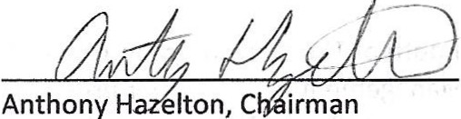SEA
BY THE BOARD OF COUNTY

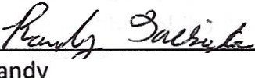

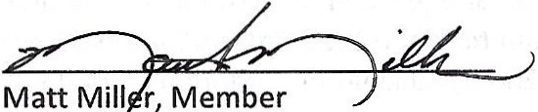
Attest: 7/J.
L
Connie M. Pretzer/unty Clerk

